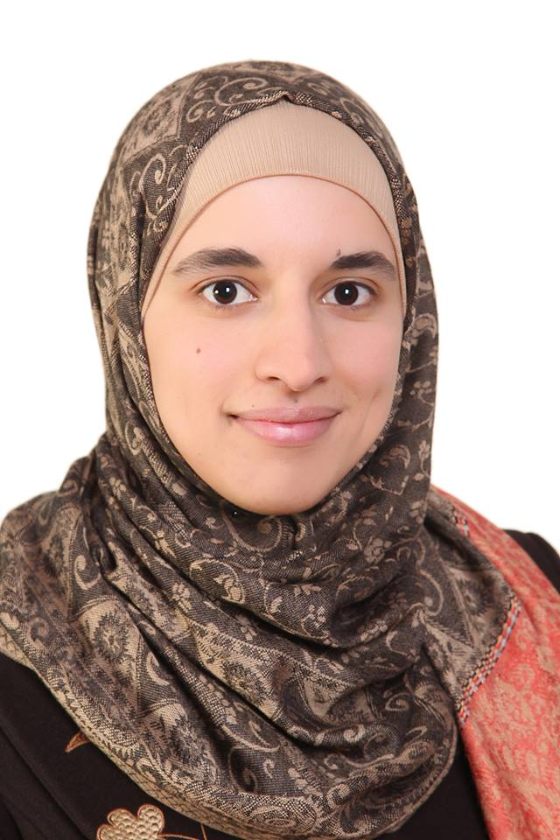

SABA TAHA EYAL SALMAN
Tla’a Al-Ali, Amman, Jordan
Mobile : +962777217163
Email: s.happy1991@yahoo.com

Personal Information:

Date of birth: 30-12-1991.
Nationality: Jordanian.
Sex: Female.
Marital Status: Engaged.
Place of birth: Tafila.
Relegion: Islam.

Objective:

As a fresh graduated engineer I’m seeking a full time challenging career to learn, improve and develop my knowledge in the engineering field. Willing to work as a team member and key player in a creative environment and high growth organization.

Education:

Tafila Technical University, Faculty of Engineering, Tafila, Jordan. (2009_2013)
BSc in Computer Engineering 2013-2014.
Grade high good.

High School Science Department: (2008_2009)
GSEC (General Secondary Education Certificate (Scientific Stream), Bsira Secondary School, Jordan. Average 81.1% (Very Good Rating) .

Languages

* Arabic: Mother Language.
* English: Very good Speaking , listening, and Writing.
Computer and programming skills

*CRM (Customer relationship management)
Microsoft office (word, power point, Excel, Acess, publisher).
C++ , Packet Tracer, Outlook, Matlab, Photoshop, Wordpress.

Skills

* Electronic Skills Embedded Systems.
* Circuit Designer, Proteus Software
* Good interpersonal communications and time management skills.
* ability to be an effective team leader.
* ability to respond positively to change.
* Team Working.
* Quick learner.
* Energetic.
* problem solving capability.
* smart & good looking.
* creative.
* enthusiastic for new ideas& knowledge.
* Working under Pressure.

